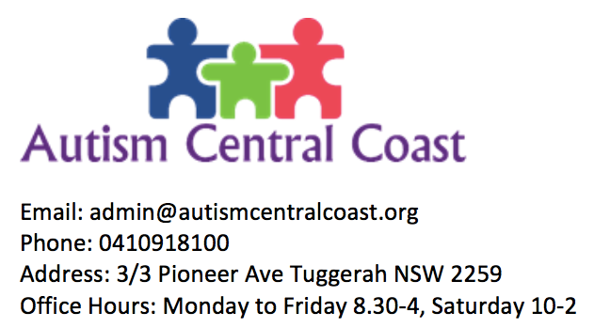

**AUTISM CENTRAL COAST PROGRAMS/ SERVICES**

**After School Program**

**Saturday Centre Program & Weekday Program**

**Saturday Community Program**

**Girls Butterfly Program**

**In-home & Community Supports**

**Short Term Accommodation / Respite**

**Supported Independent Living Home**

Modern open plan living home shared between 3 clients with 24/7 staff support, for NDIS participants with funding.

Supports with day to day management of meds, banking, cooking, cleaning and restrictive practices implemented.

**Supported Independent Living Home**

Short Term Accommodation / Respite at locations Hunter Valley, Hamlyn Terrace and The Entrance for adult NDIS participants.

**Short Term Accommodation/ Respite**

Helping clients go about their everyday life at home and within the community with the support of our carers.

Assistance in/ services include cooking, cleaning, personal care, other domestic chores, gardening, shopping, appointments and recreational activities.

**In-home & Community Supports**

**After School Program**

The After-School Centre Based Program provides a fun, friendly and relaxed environment for your child to grow and learn.

A range of activities may be carried out including cooking, arts/crafts, homework assistance, computer assistance, socialising/building relationships, sensory room activities and fun games.

Program runs from 2.30pm-6pm Monday to Friday at our Tuggerah office, transport is available.

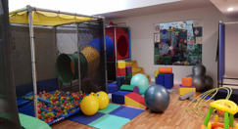

Opportunity to get involved in fun activities each Saturday out in the community.

Whether it is attending a local market, going to the beach or a park each week will be something new.

For ages 15 and over

At the Centre Based Programs participants enjoy the facilities provided here and the range of different activities carried out.

They may do arts and crafts, cook, game, keeping them entertained throughout the day.

Saturday Centre Program sessions run from 10am-2pm and are for ages 5-15.

Weekday Program sessions run from 9am-2.30pm Tuesday to Friday.

Aiming to equip participants with the ability to deal with adverse events through the teaching of life skills within a supportive and safe environment.

The program is built around the development of the following:

1. Sense of self-worth

2. Sense of control

3. Sense of belonging

4. Sense of purpose

5. Sense of future

6. Sense of humour

**Saturday Centre Program & Weekday Program**

**Saturday Community Program**

**Girls Butterfly Program**