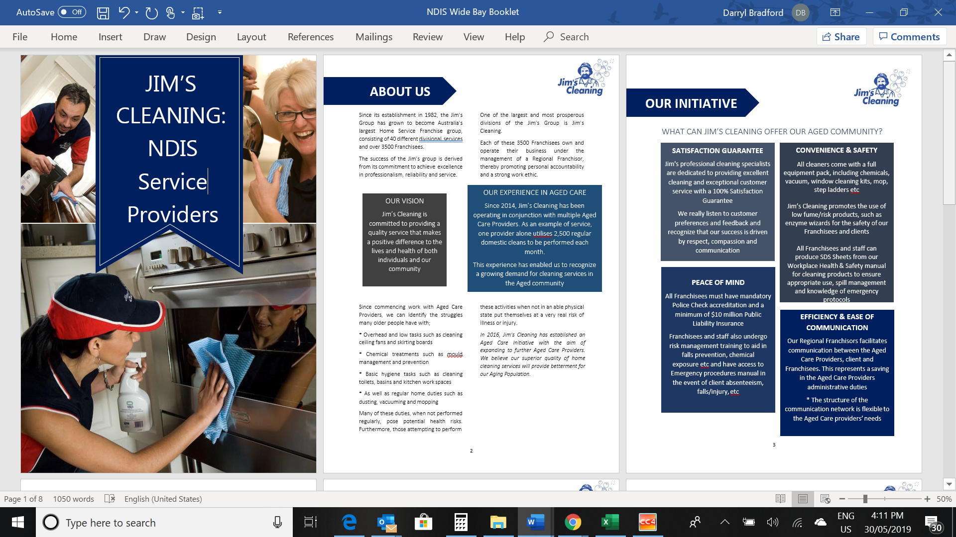

Brokering service to all

**Aged Care Providers.**

 Also 

Registered Service Providers.

**HOUSE CLEANING**

Have your home professionally cleaned under your core services.

**Our cleaning services include:**

* Regular Domestic Cleaning.
* Windows & Screens Inside and Out.
* Spring cleans – Pressure cleaning.
* House Wash and More

**LAWN / GARDEN**

* Lawn and Garden Maintenance.
* Mowing, Wiper Sniping and Hedging.
* Tree Trimming & Weeding.
* Green Waste & Rubbish removed.
* Driveway & Concrete Path cleaning.

FREE QUOTES

Call our friendly staff on Ph. 0418 576 367

(If no answer please leave your details and we will return your call)

**Local Hervey Bay Business Owners**

**Employing all Local staff.**

Jim’s Cleaning have been operating throughout the Wide Bay Area for the past 10 Years and have delivered over 28,000 domestic cleaning services for our aged clients in our community. We are now delivering services for local NDIS participants.

All our staff are - Police Checked and Trained in the services we provide.

**You have our Total Satisfaction Guaranteed on all work we do.**