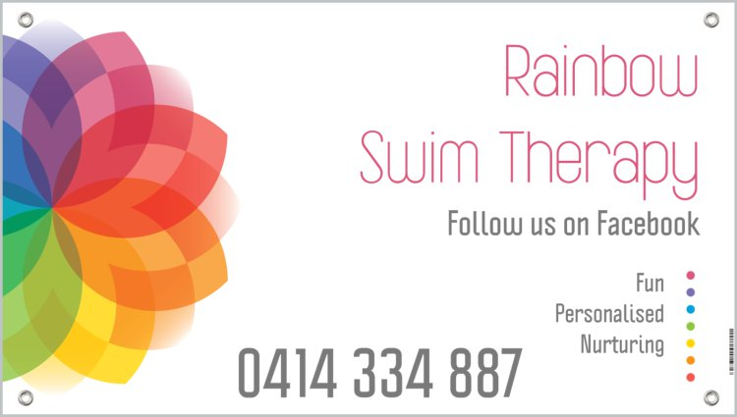

FAMILIES HANDBOOK 2019
SERVICES AVAILABLE
- “Learn to Swim”
- Aqua Aerobics
- Therapy Sessions
- Autism Swim Classes
- Stroke Development
- “Aqua Tots”
- Swim Coaching
QUALIFICATIONS

- NDIS Registered Provider #4050027402
- Registered AustSwim Provider Gold Level
- Registered AS (Autism Swim) School 2018-2019
- Teacher of Competitive Strokes Qualified Instructor
- Babies & Infants Qualified Instructor
- Blue Card Accredited Staff
- “Wets” Aqua Instructor Qualified
- Disability & Inclusion Qualified Instructor
- First Aid & CPR Accredited
- Certificate 111 in Fitness
GENERAL INFORMATION
“to swim well is an asset for Life!”
Swimming is embedded in the Australian culture and is an important part of our way of life. At Rainbow Swim Therapy we believe that every person should undertake some form of swimming education. The ability to swim well is not only potentially life – saving but is also a core life skill that will provide lasting benefits and enjoyment to all.
Small Graded Classes
All new swimmers from 4 Years and above are assessed to make sure they are placed in a class that best suits their ability. Our structured lesson formats and small class sizes ensure that each child is given focused attention to reach their potential.
No Floaties
Although we use some aids, such as hand floats and kickboards, we don’t use arm bands and back bubbles in our classes. It is easy to develop a false sense of security when using these and this can be dangerous. They also tend to keep a child’s head and body in a semi vertical position, which develops bad habits.
Fun and Active Learning
All of our classes have been designed to balance fun, exercise and correct technique. It is important to make sure swimming lessons are fun whilst ensuring kids are learning how to swim well.
Regular Updates
Feedback is important and that’s why we aim to provide all our parents with a detailed update on their child’s progress every 4 months. This is delivered personally to each parent by one of our Teachers via phone or email, to make sure swimming lessons are fun whilst ensuring kids are learning how to swim well. Newsletters are also sent out monthly to keep everyone up to date with RST. There are also regular updates on our “parents of RST” Messenger page, please make sure you are added to this group.
Accounts
Accounts for Term swimming are invoiced prior to Term commencing as is Block Swim Invoices. Be sure to keep your contact details up to date. All accounts are to be paid in Full unless prior arrangement made with RST Staff
World Class Teachers
In addition to attaining a nationally recognised qualification, all our teachers receive extensive professional development. Ongoing professional development provides additional support, so our team can provide the best lessons possible. At RST you have 24/7 access to your swim Instructors via email, Facebook or Text.
“Learn to Swim” Terms 2019:

Jan 29 – April 6 Jul 15 – Sept 21
Apr 23 – June 29 Oct 8 – Dec 14

What to Bring-

- Towel * Swim Shirt
- Sunscreen * Goggles
- Please tie long hair back * Swim Cap
- Swim nappy (if needed) * Water Bottle

Please be ready to swim when you arrive. There is a changeroom / toilet on site for your convenience.
Lessons are 30 minutes
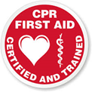
Cost $15 per lesson

Block Swim Dates:

Jan 7 – 10
Sept 23 – 26
Oct 1 – 4
Dec 16 – 19

Summer Holiday intensive block swimming lessons over the school break. Lessons will be held in weekly blocks. Each lesson will run for 60 minutes per day for Four days, at the same time each day and with the same Instructor.
To book phone Kate on 0414 334 887 or contact her through her Rainbow Swim Therapy Facebook page.

4 Day Block $60 per person
Places are limited.
AQUA Classes:
If you’re looking for a good all-round form of exercise our Aqua Aerobics sessions are just the thing for you. Running, jogging and water walking in a pool is the ultimate low impact, high cardio exercise that will strengthen the legs and hips. It is also a great way to develop cardiorespiratory fitness and the upper body also gets an overall workout.
Water acts as a cushion for the body's weight-bearing joints, reducing stress on muscles, tendons and ligaments. As a result, aquatic workouts are low impact and can greatly reduce the injury and strain common to most land-based exercises.
AQUA Classes are available three times a week.
1-hour duration
Costs $10 per class
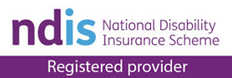
Therapy Sessions:
Aquatic therapy is movement therapy in heated water. Combining physiotherapy techniques with water-based activity has multiple benefits for patients at any level of recovery or pain management.

The natural buoyancy of the water supports your body weight and assists movement, allowing people to exercise in a safe, comfortable and low impact environment. Many people find they can move in water more easily, and with less pain, than on land.

As well as assisting movement, water can also be used to resist movement - with pool based strengthening programs and aqua aerobics available to patients.

The warmth of the water promotes blood flow – improving blood flow, flexibility and joint range of motion, along with decreasing pain, stiffness and swelling. High level balance exercises in the water are safe, and it never hurts when you fall over.
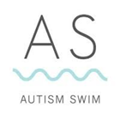
Please contact RST for Pricing

Accredited Autism Swim Program

A Nationally recognised programme that recognises the complexities of ASD and what support mechanism are necessary to educate individuals on water safety and equip them with necessary skills to be confident in the water.

Our aim is to lower the statistics of drowning deaths within the ASD population group, imparting knowledge on how individuals with ASD process and acquire skill – sets, in a fun and supportive environment.
Autism swim caters for children as young as 2, as well as adults of any age.

Autism Swim offers swimming and water consultation for those with Autism Spectrum Disorder. This involves working with families, schools and individuals to develop programs and offer recommendations.

Goals are established at the outset and resourcing can be provided to achieve these goals; resources may include visual mediums, education packages and data collection templates. We then keep in close contact to track progress and offer support along the way.

How do we teach?
We focus on four key areas:
1. Water Safety/Drowning Prevention
2. Water Therapy
3. Swimming Skill-Sets; and
4. Generalising these skills to different bodies of waters (beach, lakes etc)

Many of the programs are based on Applied Behaviour Analysis (ABA). The only interventions that have been shown to produce comprehensive, lasting results in autism have been based on the principles of Applied Behaviour Analysis (ABA).

We combine elements of instructional control, discrete trial teaching, visual imagery, reinforcement programs, shaping programs and stimulus control programs to reach the desired outcomes. Lessons are tailored to the individual in accordance with their identified needs and goals. We make it our obligation for all our lessons to not only be instructional but to also be fun for our participants.
Contact RST for Pricing/ Funding Information

Stroke Development
The aim is to improve your efficiency in the water and reduce your swimming drag.
Stroke correction is designed for swimmers who want to improve their swimming technique before taking the step of joining a swim squad. Stroke correction can also help swimmers currently attending squads needing improvement of their technique.
Limited spaces available.
HOUR SESSIONS
Please contact RST for Pricing
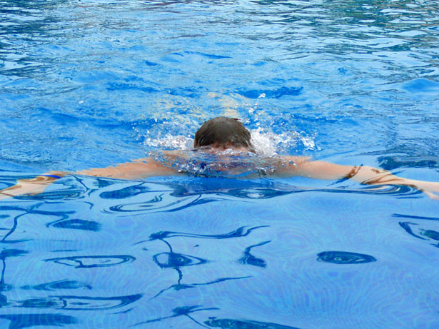

POLICIES

Payment and Attendance:
Class Fees and Annual Membership Fee ($75 per family due in Jan) must be paid in full prior to the first lesson. They are non-refundable and non-transferable. Clients are expected to attend all scheduled class sessions.
Due to course content, class schedules, and participation numbers, you may only attend the class in which you are enrolled.
Make-ups are allowed in other classes only if RST is notified of absence before 8am on day of the lesson. These are scheduled class sessions, if your child misses any classes during the session, you will not be refunded for the missed class. Regardless of your arrival time, classes will start and end at the scheduled time. Make- up Lessons are not transferrable from term to term.

Cancellations and Refunds:
RST is a Private Swim School, we have a waiting list – to be fair on everyone we run on a first in first served basis.
If RST cancels a class due to low enrolment and another suitable class is unavailable, you can receive a credit toward another session of lessons or a refund. If you cancel the enrolment at any time, two weeks’ notice must be given in writing. Approval for a refund or credit is at the discretion of RST Management.

Class Minimum Requirement:
All classes offered at RST must meet the minimum enrolment guideline. All classes not meeting minimum enrolment will either be combined with a similar class or cancelled. You will be notified by phone and/or email before the first class of any changes to the class schedule. If you have identified a second-class option, we will move your child into that class and notify you of the change.

Wait List:
If the class you are interested in is full, please ask to be added to the waitlist. We will make every effort to create another class or add another instructor to the existing class. You will be contacted if we can get you into a class.

Weather:
In the event of pool closure due to inclement weather, RST will attempt to offer a make-up lesson, credit towards a future class, or a refund. If inclement weather is in the area, RST will contact families as to the status of the pool.

Payment of Fees:
Direct Deposit: Rainbow Swim Therapy
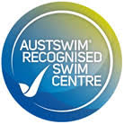
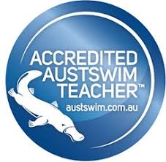
BSB: 484 799
ACCOUNT: 609149627

